Chapter 5:Inception phase

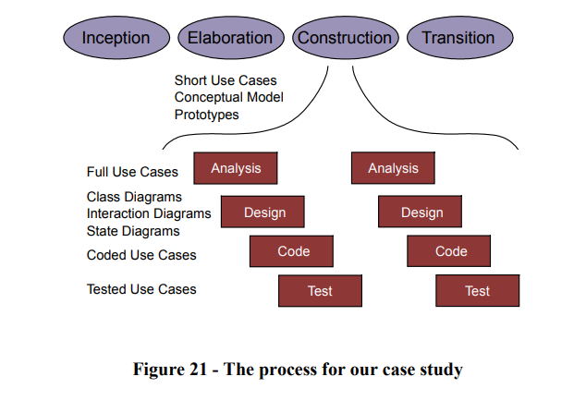

-The key activities in the inception phase are:

• Specify the vision for the product

• Produce a business case

• Define the scope of the project

• Estimate the overall cost of the project

-The size of the phase depends upon the project:

+An ecommerce project: . hit the market as quickly as possible

.activities: define the vision and get finance from a bank via the business plan

+A defence project: require requirements analysis, project definition, previous studies, invites to tender, etc …

Chapter 6: the Elaboration phase

Three main activities:

Exploring the problem in detail

Understanding the customers ‘s requirements and their business,

To develop the plan further

Note (Lưu ý)

+Get in to the correct frame of mind

+Not to get bogged down with too much detail( especially implementation)

+Need to have a very broad view of the system and understand system-wide issues.

**Prototyping**

-Aim: to mitigate of risks

The sooner risks are identified and shot down, the lesser their impact will be on the project.

Prototyping difficult or problematic areas of the project are a tremendous help in the mitigation of risks. Given that we don't want to get bogged down in implementation and design at this phase, the prototypes should be very focussed, and explore just the area of concern. (phần đỏ không cần đưa vào ppt t coppy qua để thuyết trình thôi!!!)

Prototypes can make at the end of the exercise/be reused during the construction phase.

Two models will help us with this phase: The Use Case Model and the Conceptual Model.

+The Use Case Model: help us to understand what the system needs to do, and what it should look like to the "outside world".

(ie the users, or perhaps the systems it must interface to).

+The Conceptual Model( base class model)

.This model allows us to capture, using UML, a graphical statement of the customer's problem

.describe all of the major "concepts" in the customer's problem, and how they are related.

. To build need to use the UML Class Diagram.

We will use this Conceptual Model in the Construction Phase to build our software classes and objects.